Trac Duc Anh Luong – 103488117

Task 2.2P – Question 6
1. The font type in helloworld2.html is different from helloworld.html that we created in the first week.

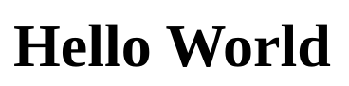


helloworld2.html helloworld.html
2. When we remove <div class=”container”></div>, the indentation of the text is removed and the text is aligned to the left border
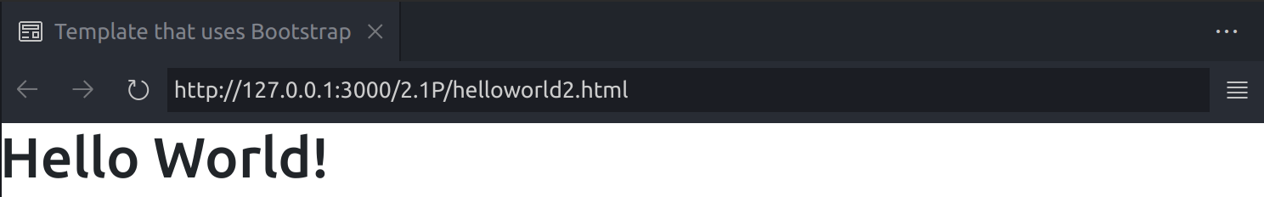
After removing the div
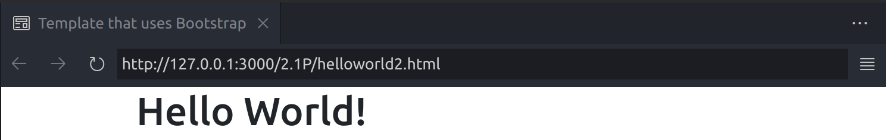
Before removing the div
3. The <div class="container"></div> structure is used to give a practical method of grouping and arranging material or items on a webpage. By giving a div the container class, you may design and control all of the contained items at once or just the container itself. The "container" class in Bootstrap is used to build a responsive, fixed-width container whose size and margins change depending on the viewport or device width. It aids in designing consistent layouts for various screen sizes.

